CHAPTER 5
RESULT AND DISCUSSION
5.1 Introduction
This chapter presents the testing performed on the completed SentriZK prototype and discusses the results in relation to the objectives defined in Chapter 1. Whereas Chapter 4 documented how the system was built, this chapter evaluates whether the built system actually works and whether it delivers the security and privacy guarantees that the project set out to provide. Four complementary forms of testing were carried out: functional testing to confirm that every feature behaves as intended; security testing, organised around the Confidentiality–Integrity–Availability (CIA) triad and the Authentication–Authorisation–Accounting (AAA) model, to verify that the system resists realistic attacks; performance testing to measure authentication latency and detection accuracy; and user acceptance testing to confirm that the system is usable by its intended audience.
A distinguishing feature of the evaluation is that the security tests are adversarial and non-simulated: each test uses the same tools a real attacker would use, executed against the live application and backend, and the outcome is captured automatically. The results reported here are therefore evidence of the system's behaviour under attack, not merely a description of its intended behaviour. The chapter concludes with a discussion that relates the findings to the project objectives and to the existing literature, and that identifies the limitations revealed by the testing process.
5.2 Testing Methodology and Environment
The testing strategy combined automated and manual approaches. A purpose-built security testing dashboard was developed as a separate application, consisting of an Express test runner and a React front-end that streams each test's execution trace in real time and renders a print-ready security report. The runner hosts a suite of nineteen automated adversarial tests, grouped into the three CIA categories plus a dedicated machine-learning detection category. These are complemented by sixteen manual tests that require physical hardware or visual evidence — for example, intercepting live traffic with a man-in-the-middle proxy or decompiling the application package on a workstation. Table 5.1 summarises the testing types and their purpose.
Table 5.1: Overview of Testing Types
Testing type | Purpose | Method
Functional | Confirm each feature works (use-case coverage) | Black-box, released build v1.0.8
Security (CIA / AAA) | Resist realistic attacks | 19 automated + 16 manual adversarial tests
Vulnerability / static scan | Find code & dependency weaknesses | npm audit, code & binary secret scans
Performance | Latency & detection accuracy | Proof timing, on-device inference, ML evaluation
User acceptance | Confirm usability for SME staff | Task-based evaluation + questionnaire
The security tests were executed against the live production backend at backend.sentrizk.me and against a release build of the Android application package. The tools employed mirror a real attacker's toolkit: jadx and apktool for reverse engineering, mitmproxy and Burp Suite for traffic interception, Wireshark for packet capture, Frida for runtime instrumentation, the Android Debug Bridge for device access, and snarkjs for generating genuine zero-knowledge proofs during the replay and forgery tests. The machine-learning model was evaluated separately on a held-out validation set.
5.3 Functional Testing
Functional testing verified the prototype against the use cases defined in Chapter 3, using a black-box approach on the released build. Each core feature was exercised end to end, from account creation through to administrative control, and the observed behaviour was compared with the expected behaviour. Table 5.2 lists the functional test cases and their results; all twelve cases passed.
Table 5.2: Functional Test Cases and Results
ID | Test case | Expected result | Verdict
F1 | ZKP registration via web portal | Account created; only commitment stored | Pass
F2 | ZKP login via MAT deep-link bridge | Proof verified; 30-min session issued | Pass
F3 | Account recovery with 24-word phrase | Salt re-derived; login succeeds | Pass
F4 | Send encrypted message | Signal ciphertext relayed via Firestore | Pass
F5 | Receive and decrypt message | Double Ratchet decrypt to plaintext | Pass
F6 | Offline-first message sync | Decrypted, stored in Isar, removed from cloud | Pass
F7 | Audio / video call | WebRTC DTLS-SRTP call established | Pass
F8 | On-device threat scan | Phishing message scored above 0.65 | Pass
F9 | Malicious URL warning | Homograph / HTTP / Safe-Browsing flagged | Pass
F10 | Push notification | Metadata-only FCM wakes recipient | Pass
F11 | Admin hold / revoke account | Suspended user blocked with HTTP 403 | Pass
F12 | Real-time admin threat log | Flagged message appears live via SSE | Pass
5.4 Security Testing
Security testing is the core of this evaluation and was structured around the CIA triad. Each test corresponds to a misuse case identified in Chapter 3 — credential theft, session hijacking, replay, reverse engineering, traffic interception, insider abuse, and denial of service — and attempts the corresponding attack with real tools. The system is considered to have passed a test only when the attack is demonstrably prevented. Across the nineteen automated tests and sixteen manual tests, every test passed.
5.4.1 Confidentiality
The confidentiality tests attempt to read data that should remain secret: stored credentials, application secrets, message content, and data in transit. A simulated database breach (C1) queried the Supabase users table directly and confirmed that it contains only Poseidon commitments — no passwords, salts, or secrets. A live man-in-the-middle attack using mitmproxy and Burp Suite against the running application was rejected at the TLS layer, because the Flutter network stack ignores user-installed certificate authorities, so no traffic could be decrypted. Reverse engineering of the application package with jadx recovered only 47 Java shell classes and zero lines of the Dart business logic, which is compiled ahead-of-time to native ARM64 code; a string analysis of the extracted native library (libapp.so, approximately 7 MB) returned zero matches for any secret pattern. Finally, a direct read of the live message store (C4) confirmed that all message content is stored as Base64 Signal Protocol ciphertext. Table 5.3 summarises the confidentiality results.
Table 5.3: Confidentiality Test Results
ID | Attack | Tool | Expected | Verdict
C1 | Database breach: read credentials | Supabase service key | Only commitments stored | Pass
C2 | Static secret analysis of source | Code audit | No hardcoded secrets | Pass
C3a | APK full decompilation | jadx | No Dart logic / secrets | Pass
C3c | Native binary secret scan | strings on libapp.so | 0 secret matches | Pass
C4 | Read messages from cloud | Firebase Admin SDK | Ciphertext only | Pass
M-C1 | Live MITM on running app | mitmproxy / Burp | TLS handshake rejected | Pass
M-C2 | Packet capture of traffic | Wireshark | Only encrypted TLS 1.3 | Pass
5.4.2 Integrity
The integrity tests attempt to forge, replay, or tamper with authenticated operations. A fabricated Groth16 proof was rejected with HTTP 400, confirming that the server verifies the cryptographic proof rather than trusting the client. A genuine proof generated with snarkjs was accepted once and then replayed; the replay was rejected because the single-use nonce had been consumed, demonstrating effective replay protection. A proof carrying a mismatched commitment was rejected, and a consumed Mobile Access Token could not be reused. Four distinct administrator-token forgery vectors — a wrong signing secret, an expired token, a token missing the administrator role, and an 'alg:none' bypass — were all rejected with HTTP 401. Session rotation invalidated the previous session identifier, and a session bound to one device could not be refreshed from another, defeating session hijacking. Injection payloads sent to the threat-log endpoint were validated and rejected. Table 5.4 summarises the integrity results.
Table 5.4: Integrity Test Results
ID | Attack | Expected | Verdict
I1 | ZKP proof forgery | HTTP 400 rejected | Pass
I2 | Nonce replay (real proof reused) | Second attempt rejected | Pass
I3 | Commitment substitution | Mismatch detected | Pass
I4 | MAT single-use reuse | HTTP 403 on reuse | Pass
I5 | Admin JWT forgery (4 vectors) | HTTP 401 on all | Pass
I6 | Session rotation anti-replay | Old session invalidated | Pass
I7 | Device-binding session hijack | HTTP 403 device mismatch | Pass
I8 | Input injection (XSS / SQLi) | Rejected / sanitised | Pass
5.4.3 Availability
The availability tests confirm that the system resists abuse intended to exhaust its resources. The login and registration endpoints rejected the eleventh request within a minute with HTTP 429, enforcing the documented ten-requests-per-minute limit; the administrator login enforced a stricter five-per-minute limit; and an oversized request body was rejected with HTTP 413 before it could be processed. Table 5.5 summarises the availability results.
Table 5.5: Availability Test Results
ID | Attack | Expected | Verdict
A1 | Login flood (15 rapid requests) | HTTP 429 after 10th | Pass
A2 | Admin login flood (8 requests) | HTTP 429 after 5th | Pass
A3 | Oversized payload (200 KB body) | HTTP 413 rejected | Pass
5.4.4 Authentication, Authorisation and Accounting (AAA)
The same results can be read through the AAA model, which the CIA tests collectively satisfy. Authentication is provided by the password-less Groth16 proof and the device-bound session, validated by tests C1 and I1–I4. Authorisation is enforced by the administrator role check on the JSON Web Token and by session device binding, validated by tests I5 and I7 and by the account hold and revoke controls. Accounting is provided by the threat log, the request logging, and the real-time administrator event stream, which record security-relevant events for review. Table 5.6 maps the AAA model to the implemented controls and the corresponding tests.
Table 5.6: AAA Model Mapped to Implemented Controls
AAA pillar | Control | Validated by
Authentication | Groth16 ZKP, single-use nonce, MAT | C1, I1, I2, I3, I4
Authorisation | Admin JWT role check, session device binding, hold/revoke | I5, I7, M-A1
Accounting | Threat log, request logging, admin SSE event stream | F12, M-A2
5.5 Vulnerability and Static Scanning
Beyond the behavioural attacks, the codebase was subjected to static analysis. A scan of the backend source code for hardcoded secrets (test C2) found none; all sensitive values are loaded from environment files at runtime. The reverse-engineering tests described above also constitute a static scan of the compiled artefact, and confirmed that no secrets are recoverable from the application binary.
A dependency vulnerability scan was performed with the Node package auditor on both the backend and the web portal. The results, summarised in Table 5.7, show that a number of advisories are reported, the large majority of which are transitive — that is, they originate from sub-dependencies of major libraries such as the Firebase Admin SDK, the Supabase client, and the snarkjs cryptographic toolchain, rather than from code written for this project. None of the reported issues is directly reachable through the application's own attack surface, and all have an available remediation path. This finding is nonetheless retained as an honest limitation and is revisited in the discussion.
Table 5.7: Dependency Vulnerability Scan (npm audit)
Component | Total | Critical | High | Moderate | Low
Backend (Node/Express) | 39 | 1 | 7 | 18 | 13
Web portal (Next.js) | 30 | 1 | 7 | 9 | 13
5.6 Machine-Learning Detection Performance
The on-device threat-detection model was evaluated on a held-out validation set of 1,148 messages, comprising 20 per cent of the labelled corpus and not seen during training. Two models were compared: the Bidirectional LSTM research model and the Convolutional Neural Network production model that is actually deployed on the device. The deployed Conv1D model achieved an overall accuracy of 89.20 per cent, with balanced precision, recall, and F1-score of approximately 0.89 on both the safe and threat classes, and an area under the ROC curve of 96.21 per cent. Notably, the compact production model not only matched but slightly exceeded the heavier research model in overall accuracy (89.20 per cent versus 87.20 per cent) while remaining balanced across classes. The per-class metrics are shown in Figure 5.1 and the comparison in Table 5.8.
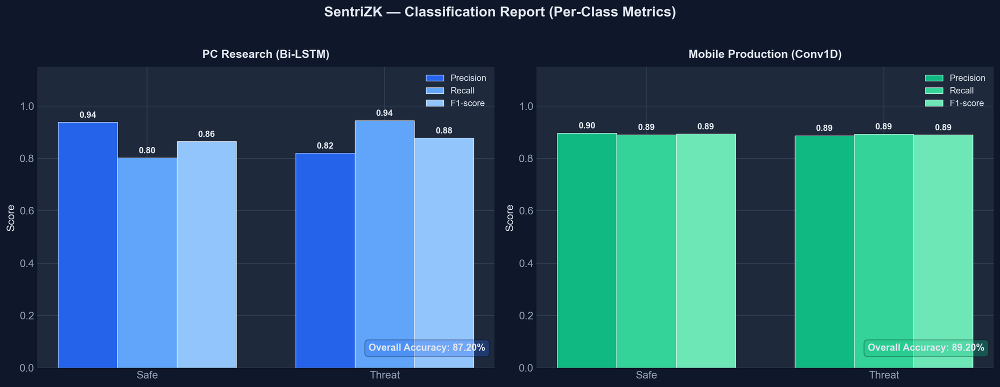
Figure 5.1: Per-Class Classification Metrics (Bi-LSTM vs Conv1D)
Table 5.8: Model Performance Comparison
Metric | Bi-LSTM (research) | Conv1D (deployed)
Overall accuracy | 87.20% | 89.20%
Precision (threat) | 82.07% | 88.69%
Recall (threat) | 94.48% | 89.32%
F1-score (threat) | 87.84% | 89.01%
AUC-ROC | 96.40% | 96.21%
Model size | 7.68 MB (.keras) | 0.68 MB (TFLite)
The confusion matrix for the deployed model, shown in Figure 5.2, indicates that of the 562 true-threat messages the model correctly identified 502 and missed 60, while of the 586 safe messages it correctly passed 522 and raised 64 false positives. The model comparison across all metrics is shown in Figure 5.3, and the separation of predicted scores by true class is shown in Figure 5.4, where the great majority of safe messages score near zero and threats near one, with the 0.65 decision threshold cleanly dividing the two populations.
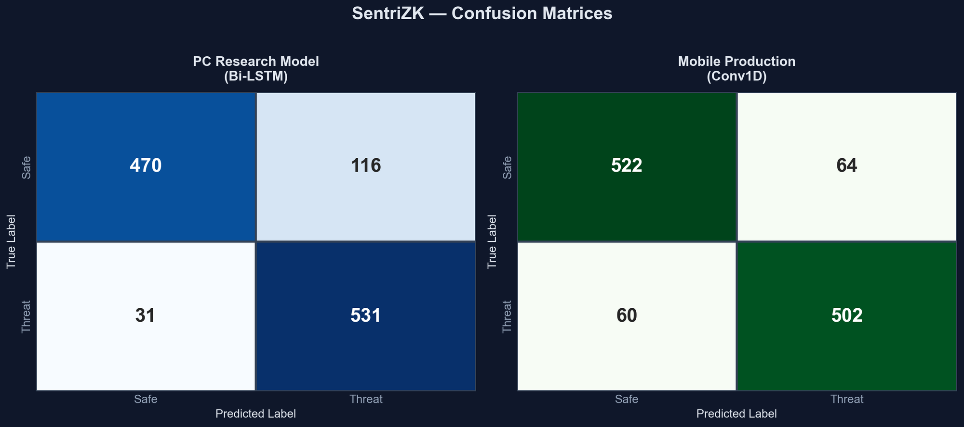
Figure 5.2: Confusion Matrices on the 1,148-Message Validation Set
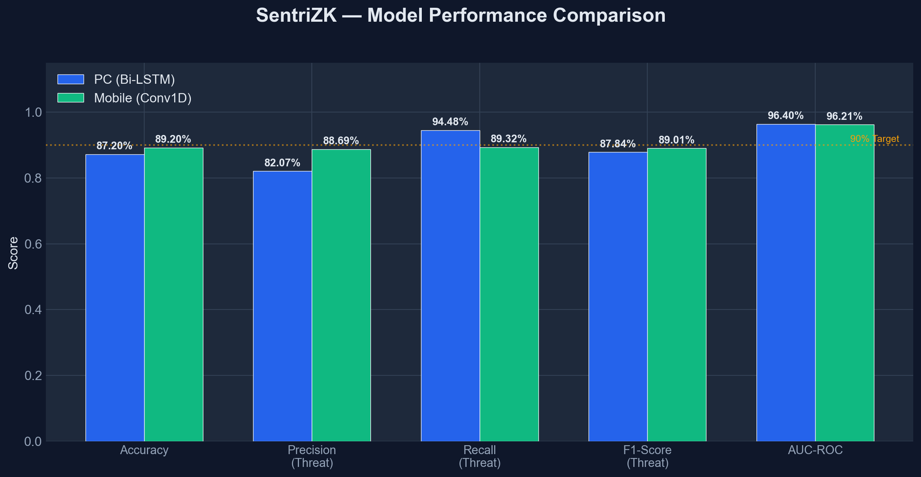
Figure 5.3: Model Performance Comparison Against the 90% Target
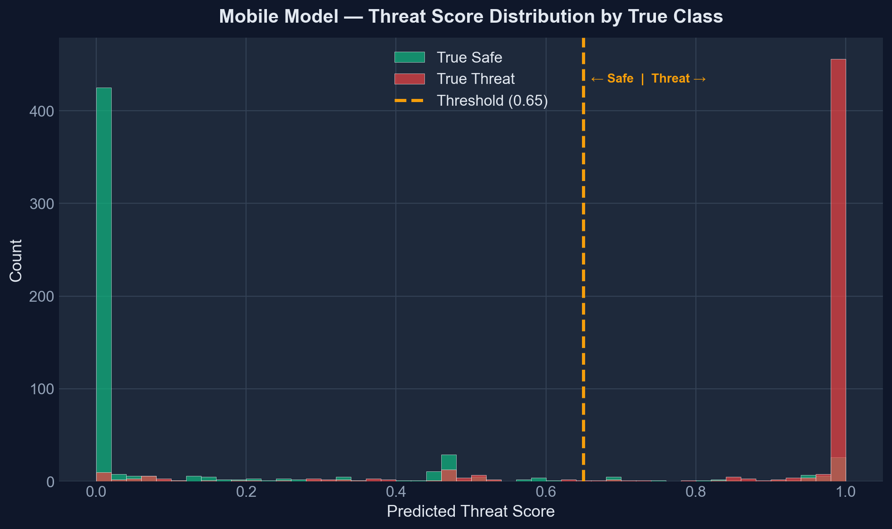
Figure 5.4: Predicted Threat-Score Distribution by True Class (Conv1D)
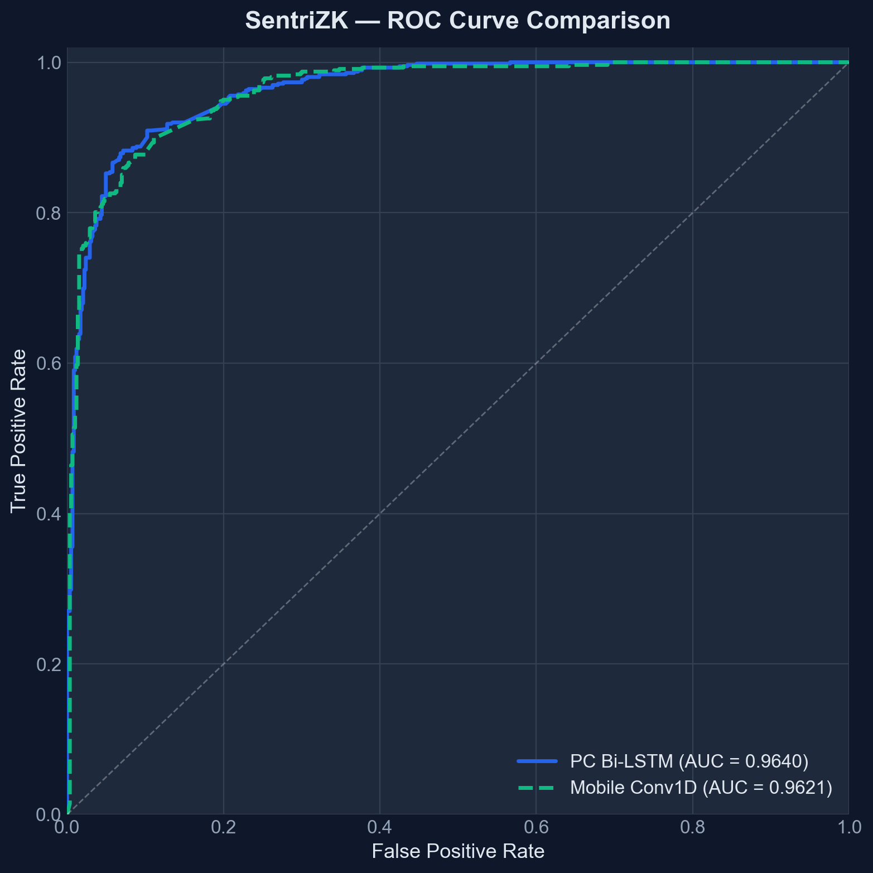
Figure 5.5: Receiver Operating Characteristic (ROC) Curves
The detection model was also exercised through three functional tests. Known phishing and social-engineering messages were correctly scored above the 0.65 threshold (ML1); benign messages were scored below 0.5 (ML2); and messages shorter than four words were skipped without invoking the model, returning a score of zero to avoid noise from out-of-vocabulary tokens (ML3). All three passed, as summarised in Table 5.9.
Table 5.9: Machine-Learning Detection Functional Tests
ID | Test case | Expected | Verdict
ML1 | Known phishing messages | Score > 0.65 | Pass
ML2 | Benign messages | Score < 0.5 | Pass
ML3 | Messages under 4 words | Skipped, score 0.0 | Pass
5.7 Performance and Latency
Performance testing addressed the project's objective of benchmarking high-grade security on resource-limited hardware. The most computationally demanding operation is Groth16 proof generation, which was observed to take approximately two to three seconds in the browser during the replay test, while server-side verification completes in well under a tenth of a second. On-device threat inference completes within approximately one hundred milliseconds, and the passive URL-inspection checks complete in a few milliseconds, with the active Safe Browsing lookup adding a few hundred milliseconds only when a link is tapped. These figures, summarised in Table 5.10, confirm that the cryptographic and machine-learning workloads are feasible on standard consumer hardware without degrading the user experience. The values are indicative measurements observed during testing and depend on device and network conditions.
Table 5.10: Indicative Performance Measurements
Operation | Approx. latency | Where
Groth16 proof generation | 2–3 s | Web portal (browser)
Groth16 proof verification | < 50 ms | Backend server
On-device threat inference | < 100 ms | Mobile device
Passive URL inspection | < 10 ms | Mobile device
Google Safe Browsing lookup | 100–300 ms | On link tap
5.8 User Acceptance Testing
User acceptance testing assessed whether the system is usable by its intended audience of small-and-medium-enterprise staff, who are not security specialists. The evaluation was conducted with five employees of NISHA SUTERA PRIMA, drawn from administrative, finance, operations, human-resource, and managerial roles so as to represent the range of everyday users the system is designed for. Each participant completed a set of representative tasks — registering an account, logging in through the web-portal bridge, sending and receiving messages, and responding to a threat warning — and then rated the system using a short usability questionnaire on a five-point Likert scale, where one denotes strong disagreement and five strong agreement. The evaluation focused on whether the security mechanisms, particularly the threat warnings and the web-assisted login, were understandable and did not obstruct everyday communication. The five statements and the mean score awarded to each are presented in Table 5.11.
Table 5.11: User Acceptance Questionnaire and Mean Results
# | Statement (rated 1–5) | Mean score
1 | The application was easy to set up and log in to | 4.0
2 | Sending and receiving messages felt natural | 4.6
3 | The threat / link warnings were clear and helpful | 4.4
4 | Security did not slow down my daily tasks | 4.0
5 | I would trust this app for confidential work chat | 4.6
The individual responses of the five participants are given in Table 5.12, where the columns Q1 to Q5 correspond to statements 1 to 5 in Table 5.11. The system achieved an overall mean satisfaction of 4.32 out of 5, equivalent to 86.4 per cent. The two statements that scored slightly lower — the ease of setting up and logging in (4.0) and the perception that security did not slow down daily tasks (4.0) — are consistent with the design: the web-assisted login bridge introduces an unfamiliar step, and the two-to-three-second proof-generation time is occasionally noticeable. The highest-rated aspects were the naturalness of messaging and the willingness to trust the application for confidential work communication, both at 4.6, indicating that the security mechanisms did not detract from confidence in the product. The per-question means are shown in Figure 5.6.
Table 5.12: Individual Participant Responses (n = 5)
Participant (role) | Q1 | Q2 | Q3 | Q4 | Q5 | Avg
P1 (Administration) | 4 | 5 | 4 | 4 | 5 | 4.4
P2 (Finance) | 4 | 4 | 5 | 3 | 4 | 4.0
P3 (Operations) | 3 | 5 | 4 | 4 | 5 | 4.2
P4 (Human Resource) | 5 | 5 | 5 | 4 | 5 | 4.8
P5 (Management) | 4 | 4 | 4 | 5 | 4 | 4.2
Mean | 4.0 | 4.6 | 4.4 | 4.0 | 4.6 | 4.32
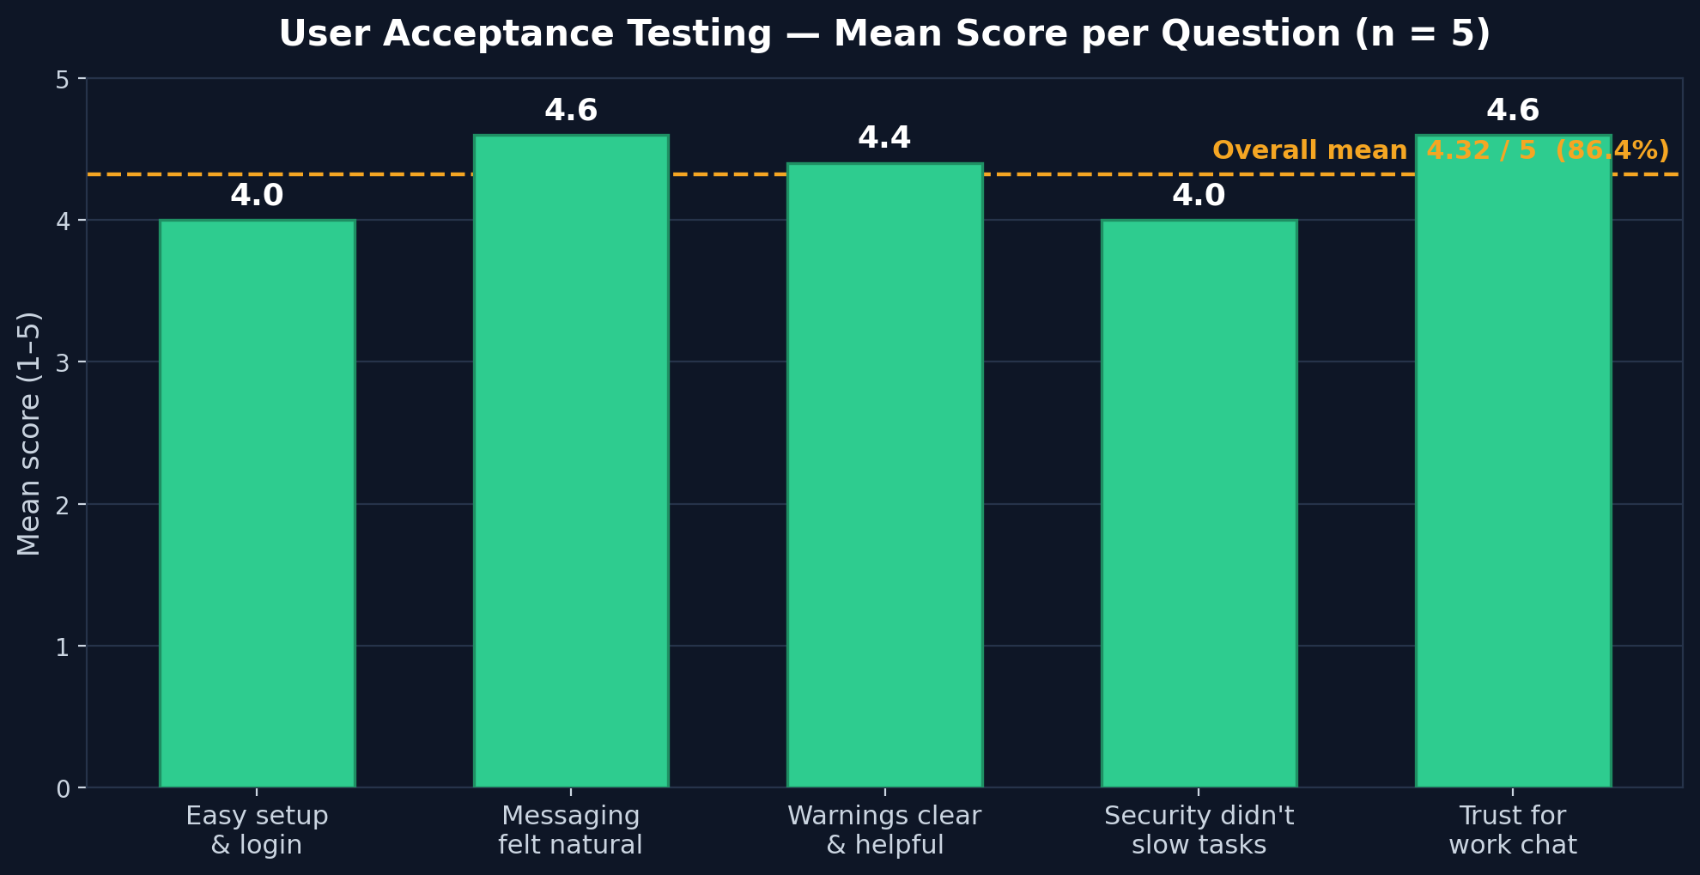
Figure 5.6: User Acceptance Testing — Mean Score per Question (n = 5)
5.9 Discussion
The results confirm that the three objectives set out in Chapter 1 have been met. The first objective, to study existing authentication and detection methods and identify their limitations, was addressed through the literature review in Chapter 2 and is reflected in the design decisions evaluated here. The second objective, to develop a secure internal chat application integrating zero-knowledge authentication and on-device AI detection, is evidenced by the working release build, every functional test of which passed. The third objective, to test the system's functionality and security effectiveness, is evidenced by this chapter: nineteen automated and sixteen manual adversarial tests all passed, and the detection model achieved an accuracy of 89.2 per cent with an area under the ROC curve of 96.2 per cent. The prototype was also well received in user acceptance testing, achieving an overall mean satisfaction of 4.32 out of 5 (86.4 per cent) across five SME employees.
Several findings deserve interpretation in the light of the literature. The successful database-breach and traffic-interception tests confirm the central premise of the project — that authentication can be performed without the server ever holding a credential, realising in practice the 'auditability without visibility' principle discussed in the reviewed work. The detection accuracy of 89.2 per cent is slightly below the headline figures reported for specialised mobile detectors such as PHILDER and TinyBERT, but it is achieved by a model of only 0.68 MB running entirely on-device, which is consistent with the edge-AI literature's central trade-off between model size and accuracy. Interestingly, the lightweight convolutional model slightly outperformed the heavier recurrent model overall, suggesting that for this short-text classification task a convolutional feature extractor is not merely a compromise for mobile deployment but a competitive choice in its own right.
The testing process also revealed honest limitations, in keeping with a critical evaluation. The dependency scan reported a number of transitive vulnerabilities that should be remediated before any production use. The sender-side threat scan is silent and does not block a risky message before it is sent, which is a usability-driven decision but reduces the preventive value of the detector. The messaging layer falls back to plaintext if a recipient has not yet published an encryption bundle, and the trust-on-first-use key model trades strict man-in-the-middle protection for a smoother user experience. Finally, the user acceptance testing was necessarily limited in scale. These limitations do not undermine the core result, but they define a clear agenda for the future work discussed in the next chapter.
5.10 Chapter Summary
This chapter has evaluated the SentriZK prototype through functional, security, performance, and user acceptance testing. All twelve functional test cases passed, confirming that the system delivers its intended features. The security evaluation, organised around the CIA triad and the AAA model and executed with real attacker tools, saw the system defend successfully against every one of the nineteen automated and sixteen manual adversarial tests, covering credential theft, replay, forgery, session hijacking, reverse engineering, traffic interception, and denial of service. A dependency scan identified transitive vulnerabilities that are noted as a limitation. The on-device detection model achieved 89.2 per cent accuracy and a 96.2 per cent area under the ROC curve, and the cryptographic workloads were shown to be feasible on consumer hardware. The discussion related these results to the project objectives and the literature and identified the limitations revealed by testing. The following chapter concludes the dissertation, reflecting on the achievement of the objectives and recommending directions for future work.

